**ENHANCING ELECTRICAL EDUCATION: UNDERSTANDING AC AND DC MOTOR CONTROL SYSTEMS**

A book report presented in Meng 135 - DC and AC Machinery

Submitted by:

Balbarino, Vic Marie L.

Basan, Jojules T.

Casas, Troibert Sam P.

Larena, Sean Clej E.

Oftana, Dominador Jr. A.

Ramirez, Leander P.

Tabucanon, Romulo Y.

Submitted to:

Engr. Philip Caesar L. Ebit

December 2023

**TABLE OF CONTENTS**

INTRODUCTION 3

Objectives 3

METHODOLOGY 4

A. Start-Stop Control for Single-Phase Motor (Timer-on and Timer-off Delay) 4

A.1. Start -Stop Control for Single-Phase Motor with Timer-On Delay 4

A.2. Start-Stop Control for Single-Phase Motor with Timer-Off Delay 5

B. Start-Jog-Stop Control For Single-Phase Motor 6

B.1. Start-Jog-Stop Control for Single-Phase Motor with Timer-On Delay 7

C. Forward-Reverse Control for Single-Phase and Three-Phase Motor 8

RESULTS AND DISCUSSION 11

CONCLUSION 13

REFERENCES **14**

# 

# INTRODUCTION

Technology never stops innovating. Modernization goes with it rapidly. Thus, education today needs to rise to the call of time through encouragement and equipping laboratories with trainers which can be used to help students understand the basics in the world of digital electronics [1]. The AC/DC Training System is a state-of-the-art training system that is specifically designed to introduce students to the basic principles of electrical circuits, both in direct current (DC) and alternating current (AC). It provides a comprehensive, high-quality, and cost-effective solution to rapidly build student knowledge in electricity and electrical circuits. The Trainer provides an alternative to traditional teaching methods and laboratory setups and will ultimately save cost and space while affording flexibility and practical knowledge to today's students [2].

Learners will see how electricity is used for power and control in industrial, commercial, agricultural, and residential applications. This training system covers industry-relevant technical skills including how to operate, install, design, and troubleshoot basic AC and DC electrical circuits for various applications [3]. In this book report, we will explore different types of AC and DC Trainer setups. These include Single-phase Motor Start-Stop Control (Timer-on and Timer-off Delay), Single-phase and Three-phase Motor Forward-Reverse Control, and Single-phase Motor Start-Jog-Stop Control. We will explore how they work, what are the connections needed to achieve those setups and how useful they are in real life.

## Objectives

Generally, this paper aims to provide a comprehensive report on executing diverse motor control exercises, provide demonstrations, circuit diagrams, troubleshooting techniques, and safety protocols

Specifically, this paper aims to:

1. To explore the basic principles of AC and DC Trainer;

2. To explain how to perform different trainer strips namely: Single-phase Motor Start-Stop Control (Timer-on and Timer-off Delay); Single-phase and Three-phase Motor Forward-Reverse Control; and Single-phase Motor Start-Jog-Stop Control.

3. To evaluate our learnings in AC and DC Motor Control and its applications.

**METHODOLOGY**

This chapter explains and guides the readers through the step-by-step process of using the trainer for various applications. Throughout the process, these applications are accompanied by an appropriate circuit diagram and explanation. The course covers three applications: single-phase motor start-stop control (timer-on and timer-off delay), single-phase and three-phase motor forward-reverse control, and single-phase motor start-jog-stop control.

## A. Start-Stop Control for Single-Phase Motor (Timer-on and Timer-off Delay)

Start-stop circuits are a basic component of electrical systems and are critical in controlling machinery and processes. These circuits are widely used in various control systems which enable the activation or deactivation of motors, machines, or entire production processes.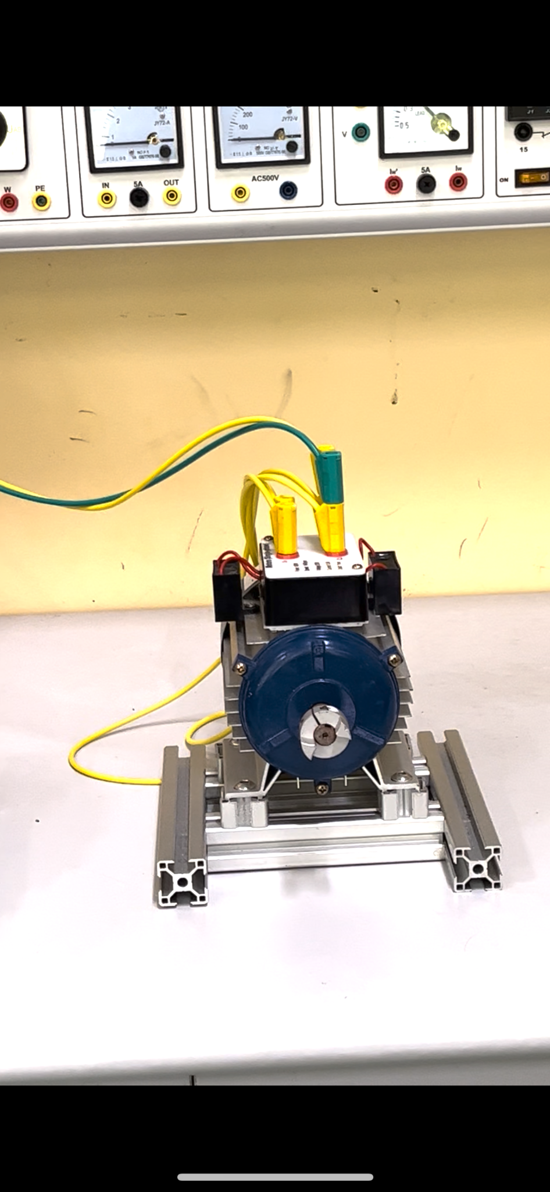

Figure 2.1. Single-phase Motor

### A.1. Start -Stop Control for Single-Phase Motor with Timer-On Delay

Figure 2.2. Start-Stop Control with Timer-on Delay Diagram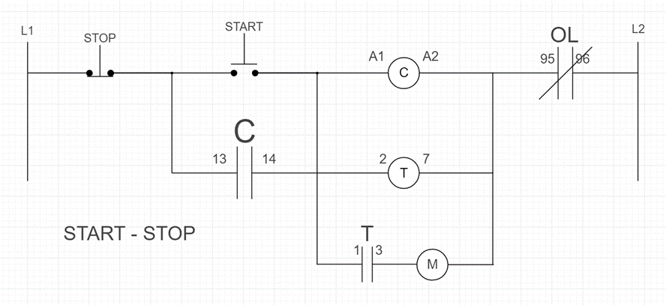

For a Start-Stop Control for a Single-Phase Motor with Timer-On Delay, the Figure 2.1 above shows the circuit diagram to be used. To begin with, as we noticed on the ladder diagram, the L1 is connected to the stop button, which is a normally closed button. This button serves as a button for stopping the operation of the motor. It is then that the stop button is connected to a normally open button which if pushed or activated it will start the operation of the motor (you can choose from the three buttons). Then, it is connected to the magnetic contactor terminals A1 and A2 terminal to the thermal relay terminals 95 and then terminal 96 connects with the L2 of the power source.

After the first ladder is successfully connected, latching is needed for the Start Button, when the button is pressed, a latching happens in the contactor, the button that is being “latched on” will automatically “ON” until the STOP button is pushed or activated. After the wiring in the latch is done make a parallel connection from terminals A1 and A2 to the terminals 2 and 7 of the electronic time relay module.

Consequently, the terminal 1 from terminal 2 of the electronic time relay module and the terminal 3 to the L1 of magnetic contactor and the T2 of the contactor will connect to the motor and then connect the motor to the T2 and the L3 to L2 of the power source, set the electronic timer relay module for 5 seconds.

In wiring the Single-Phase Motor, a person has the liberty to choose from two types of connection shown in the motor.

### A.2. Start-Stop Control for Single-Phase Motor with Timer-Off Delay

Figure 2.3. Start-Stop Control with Timer-on Delay Diagram

For Timer-off Delay, it’s basically almost the same connection with the timer-on delay, the only difference is in the connection for the electronic time relay module. First, as shown in the figure above, L1 is connected to a stop button which is a normally closed button, then the stop button is in series with another button-the start button which is a normally open button. Stop Button's main role is to halt the operation pronto while the start button’s role is to start the operation. A series connection is established from the start button to the terminal A1 and A2 of the magnetic contactor. Then from A2, a connection is established to the terminals 95 and 96 of the OL or the thermal relay, and to close the circuit, a connection from terminal 96 to L2 of the power source is established.

Consequently do the latching by establishing a parallel connection from your start button to the normally open auxiliary terminals 13 and 14 of the magnetic contractor. After that, a parallel connection also ran from the A1 and A2 terminals of the contactor to the terminals 2 and 7 of the electronic time relay module. With that being established, make a connection from terminal 2 of the electronic timer relay module to its subsequent terminal 1 and also at terminal 4 of the same module connect the latter to the L1 of the magnetic contactor (you can notice a multicolored terminals), and at T2 connect to the Single Phase Motor and the out of the motor will be connected to the T4 terminal of the same magnetic contactor and at L3 a connection from it to the L2 of the power source is established. Lastly, adjust the timer gauge for your time preference to when the delay starts.

## B. Start-Jog-Stop Control For Single-Phase Motor

On top of the list, safety must be one of your major priorities when conducting a motor control practice or training. Electricity, high voltages to be specific, is deadly when mishandled. An individual can't befriend electrical currents, thus, handling and appropriate guidelines must be satisfied before proceeding.

Focusing on this circuit, the start-stop-jog motor control is used to momentarily energize the circuit without pressing the stop pushbutton. This jogging circuit utilizes a control relay or contactor which behaves like motor starters but lacks overload protection and power contacts. Moreover, the contactor must be connected in parallel with the motor to ensure that it gets its rated voltage.

Under normal or standard conditions, if the start button is pressed, the circuit will be complete and energize the contactor, control relay. Once the contactor is energized and the latching is successful, this will provide a path for the current to energize the motor, which also results in the normally open contacts to change their state and close.

If the jog button is pressed while the motor is running, there will be no changes to the circuit. However, if the jog button is pressed while the motor is not running, it will provide a path for the current to energize the motor. In the process, the current won't go and be able to energize the contactor. Once the jog button is released, the starter drops out of voltage and the motor will stop. 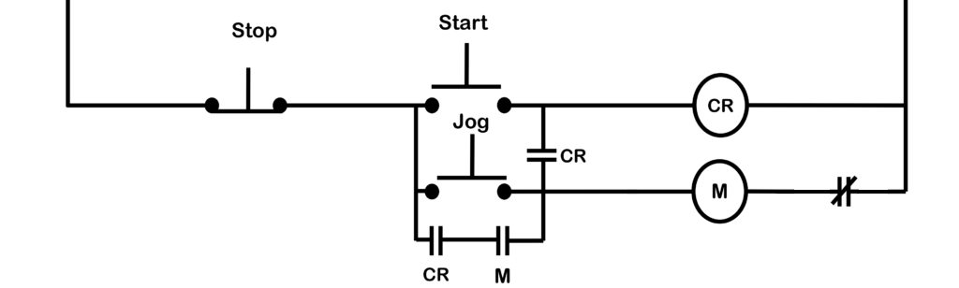

Figure 2.4. Start-Jog-Stop Control Circuit Diagram

### B.1. Start-Jog-Stop Control for Single-Phase Motor with Timer-On Delay

Explaining the connections, the L1, positive voltage terminal, will be connected to the normally closed terminal of your desired stop button. It is then connected to the normally open terminal of your assigned start button proceeding to the voltage sources of the contactor (A1, A2). Next, A2 must be connected to the L2, negative voltage terminal, of the trainer. This will create a circuit, but lacks the jog button. To create a jogging action of the motor, an individual must connect the normally open terminal of your jog button to the output terminal of the stop button. This will result in creating a parallel connection with the start button.

Focusing on the jog button, an individual must create a connection with the start button's output terminal using a normally open terminal of contactor. While doing so, the individual must connect, in parallel, the jog button to a normally open terminal of the contactor proceeding to the power terminal of the motor starter. After proceeding, the motor starter must then be connected to the thermal relay or overload relay. This is to provide voltage protection to the circuit. This protection stops until the stop button is pressed or an overload occurs.

Revolving around the motor starter, it is specified to use a single-phase motor starter. Motor polarities and connections are explained and can be readily learned through practice.

## C. Forward-Reverse Control for Single-Phase and Three-Phase Motor

Figure 2.5. Forward-Reverse Diagram

For this circuit, we will be utilizing two motors, specifically; Single- and Three- phase motors.

To begin the circuit, a connection is made between the power source (positive terminal) and one terminal of the normally-closed button, which serves as the circuit's stop button. It is then connected to one terminal of the normally-open button for the forward circuit from the other terminal of the stop button. It is then connected to the reverse contactor's auxiliary normally-close terminals. The reverse contactor's auxiliary normally-closed terminal is then connected to the forward contactor (A1). A latch is then connected in parallel to the normally-open button, allowing current to flow after the button is pressed. This is required because the button used is not a momentary button. A connection is made from the contactor to the "overload," which is the circuit's safety measure. To complete the circuit, a line is connected from the overload to the source (negative terminal).

For the reverse circuit, it is similar to the Forward circuit, but in reverse. To supply the circuit with power from the power source, we will create a parallel connection from the power source towards one terminal of a different normally-closed button. It is then connected to the forward contactor's auxiliary normally-close terminals. The forward contactor's auxiliary normally-closed terminal is then connected to the reverse contactor (A1). A latch is then connected in parallel to the normally-open button. A connection is made from the reverse contactor to the "overload".

After connecting the forward and reverse contactors, we can now start with the motor connection. In the single-phase motor, we can connect the terminal in the motor by series or parallel. We would connect it from either the forward or reverse contactor. To connect the motor, we will start by connecting a supply from the power source to the normally-open terminal of the contactors (1/L1). Then, from the contactor (2/T1), we will contact it to the positive terminal of the motor (U1 for series/ U2 for parallel). Another connection is created from the negative terminal (V1 for series/ V2 for parallel) to the normally-open terminal of the contactors (4/T2). To close the circuit, we will connect the outlet of the negative side (3/L3) to the negative terminal of the trainer (L2).

For the three-phase motor, we would connect it by either delta or “Y” connection. For the delta we will connect Z to A, X is connected parallel to A, X is connected to B, Y is connected parallel to B, Y is connected to C, and C is parallel to Z (refer to figure #, for the circuit diagram). For the “Y” connection, we will connect X to A, Y to B, and Z to C. From A and C, we will connect them parallel to B (refer to figure #, for the circuit diagram). To connect the motor, begin by connecting a power supply to the normally-open terminal of the contactors (1/L1). The contactor (2/T1) will then be connected to the positive terminal of the motor. Another connection is made between the contactors' normally-open terminals and the negative terminal (V1 for series/V2 for parallel). To complete the circuit, connect the negative side's outlet (3/L3) to the trainer's negative terminal (L2).

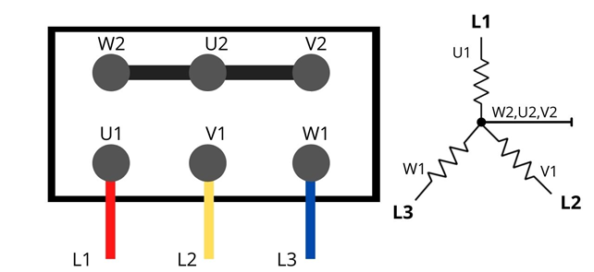

Figure 2.6. Delta Connection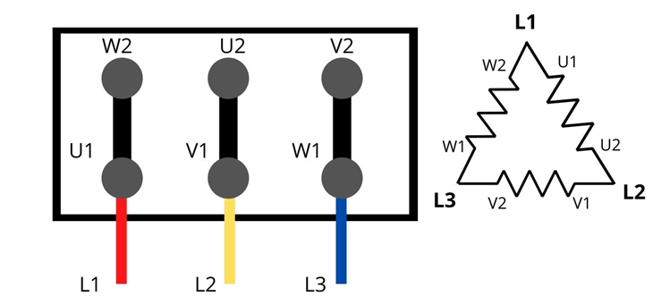

Figure 2.7. Wye Connection

Figure 2.8. Three-Phase Motor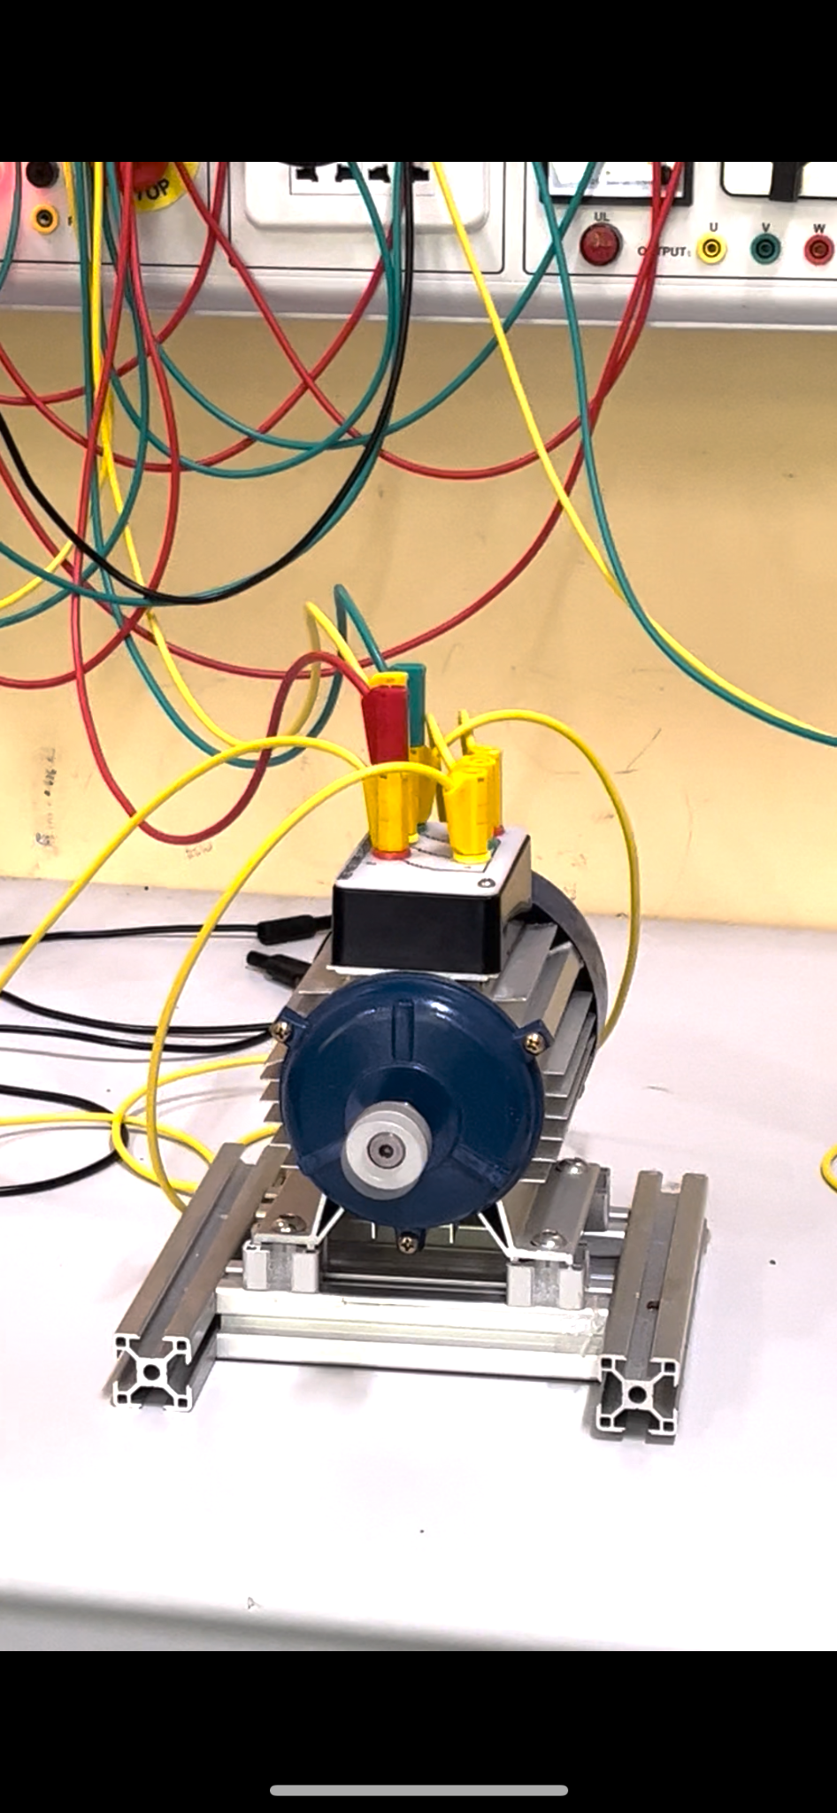

# RESULTS AND DISCUSSION

Figure 3.1. AC and DC Trainer

The AC and DC Motor Trainer is a device designed for learning how to control motors especially in industrial settings with different types of connections. In this paper, four of the controls were used; the Single-phase Motor Start-Stop Control (Timer-on and Timer-off Delay), Single-phase Motor Start-Jog-Stop Control, and Single-phase and Three-phase Motor Forward-Reverse Control.

The connection, Start-Stop Control Timer Off Delay, we, the operator, gets to decide how long the motor keeps running after you stop it. This was done by connecting the L1 to the STOP button then to the START button and connecting it to the contactor which is the A1 and goes out to the A2. It then goes to the thermal relay in the 95, goes out to the 96 and to the L2 of the power source, closing and making the connection in series. Another connection is made from the from the normally closed socket the start button, which was connected to the contactor in the normally open 13 and goes out in the 14. It then goes back to the normally open socket of the start button. This made the start button paralleled to contactor and motor. The connection turned the motor on without any timer delay. This is akin to determining the duration a fan stays on after being switched off, giving you control over post-operation timing.

Figure 3.2. Start-Stop Control with no timer in a DC Motor Trainer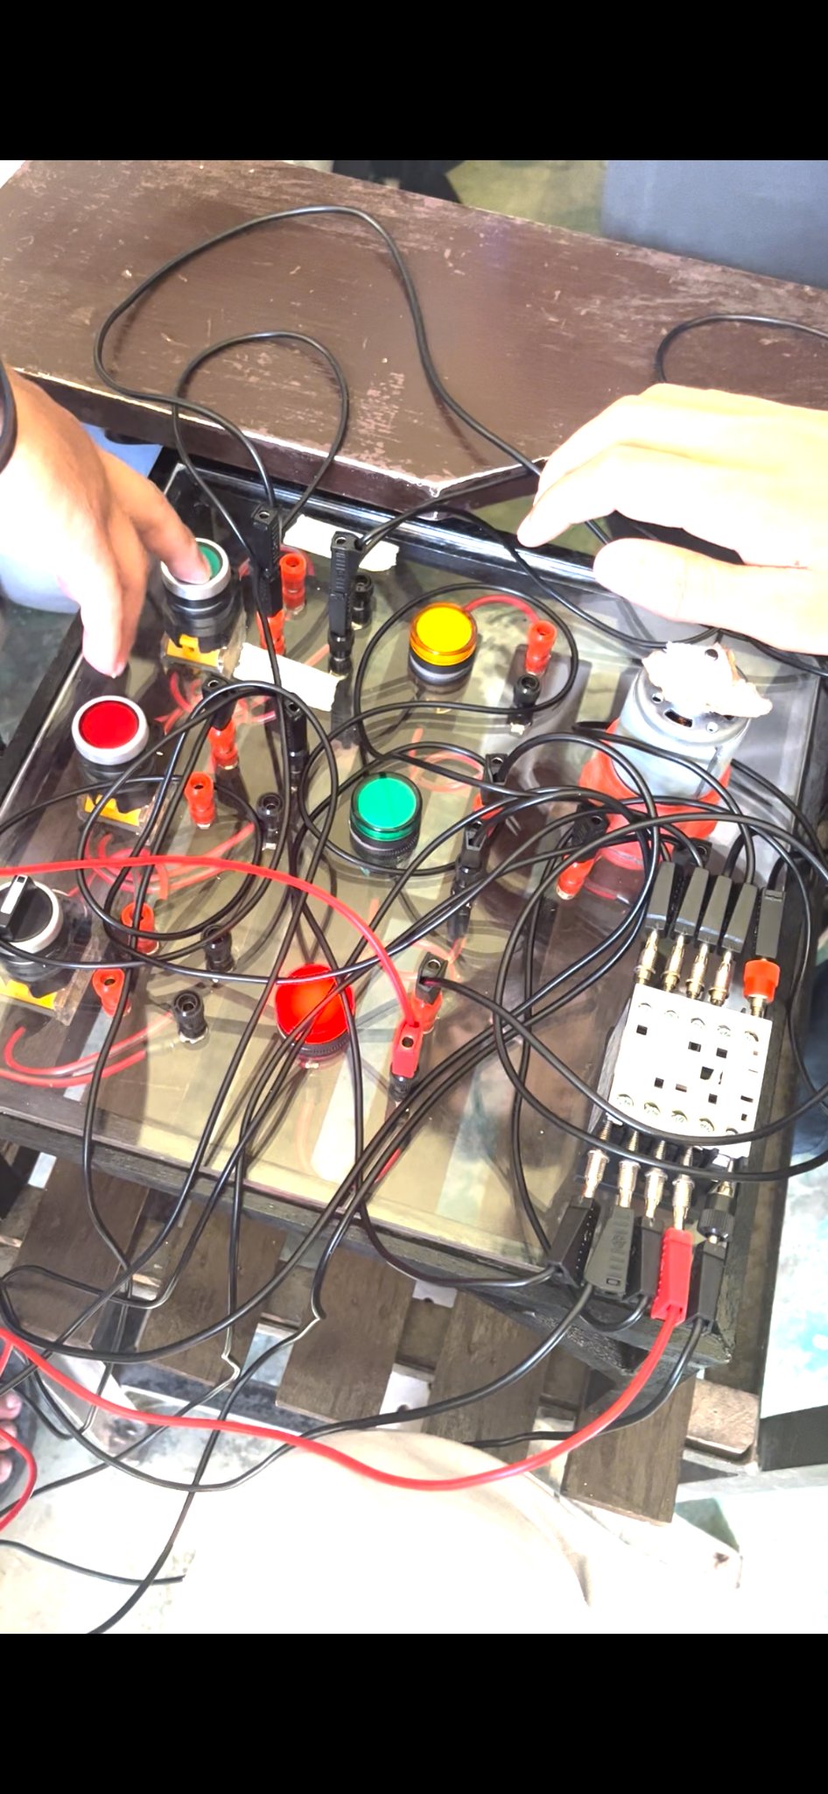

In the Start-Stop Control with the Timer On Delay, we were able to set up a timer for when the motor should start after pressing a button. It's like a delayed kick-off, allowing you to control the timing of motor activation. It has mostly the same connection from the timer off-delay, wherein the only difference is that there are connections from the timer and load and has the same connection to the motor to start it. The operator can also modify how much time is delayed either from 3, 5, and 9 seconds. The connection for both approaches uses the same connections, where the AC Motor Trainer can utilize both approaches (with timer-off and timer-on), whereas the DC Motor Trainer can only utilize the timer-off delay.

The Forward-Reverse connection type enabled us to control the motor to rotate in a clockwise or counterclockwise direction, offering reversible functionality. Much like a fan that can change its rotation direction. This type of connection has two three-pole contactors needed, each which powers the motor in different phases, the Forward and Reverse. When the forward contactor is energized, power contacts connect line L1 to T1, line L2 to T2 and line L3 to T3 at the motor. This opened the connection for the reverse because it is connected to the 2nd contactor that is normally closed. It then turns off the connection and will not energize the contactor. Both contactors will not operate at the same time because both are latched and will likely cause a problem if it should occur. When the reverse contactor is energized, the power contacts that are connected to L1, L2, and L3 at the three phase motor, will cause the 1st contactor, which is the assigned contactor for the forward connection, to have an open connection. The contactor will not be energized because it is connected in a normally close connection. Both are in a series connection to the overload relay to prevent an overload circuit that will likely cause the device to heat up or burn.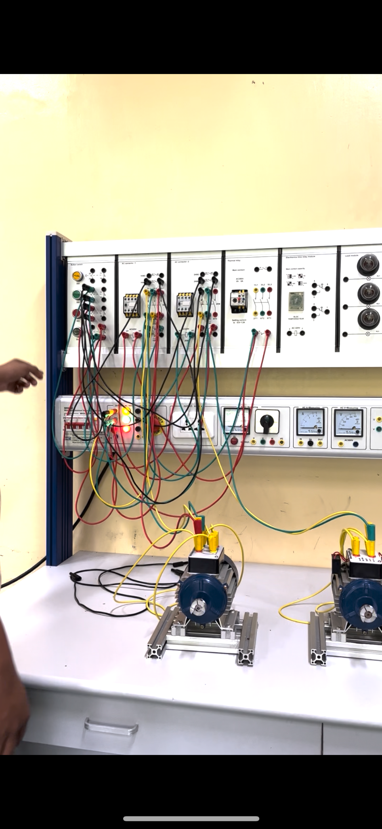

Figure 3.3. Forward-Reverse Control for Single-Phase and Three-Phase Motor on the AC Trainer

The Start-Stop-Jog, making things a step further, is a configuration that allows us to not only start and stop the motor but also to give it a little nudge (jog) whenever we want. When the operator presses the jog button, the circuit closes briefly, thus current will pass through the circuit and energize the contactors causing the motor to run momentarily. When the relay is activated, the two normally open contacts connected to it change state and close. This will allow electricity to flow into the motor starter, closing the 2-3 holding contacts and starting the motor. In practical applications, jog circuits act as a test connection for the motor. It adds an extra layer of control, providing a dynamic way to interact with the motor. It's a hands-on and engaging approach to understanding how motors operate in various scenarios.

# CONCLUSION

The use of AC and DC trainers in educational and vocational settings has emerged as an invaluable tool for students entering the world of electrical systems. These trainers act as hands-on learning platforms, allowing students to gain a practical understanding of alternating current (AC) and direct current (DC) principles. Learners gain firsthand experience in constructing, analyzing, and troubleshooting circuits through comprehensive modules and practical exercises, bridging the gap between theoretical knowledge and real-world applications.

Furthermore, the importance of AC and DC trainers goes beyond basic circuitry understanding. These training systems promote the development of critical skills, problem-solving abilities, and proficiency in circuit design, analysis, and maintenance. Students develop a deep understanding of electrical principles as they experiment with various circuits and investigate the nuances of both AC and DC systems, preparing them for the complexities of modern electrical engineering challenges.

In addition, the adaptability and scalability of AC and DC trainers make them indispensable in educational institutions. These trainers can accommodate different skill levels and learning objectives due to their ability to simulate various scenarios and circuit configurations. Their role in honing practical skills, reinforcing theoretical concepts, and instilling confidence in working with electrical systems solidifies their position as foundational assets in shaping competent and adept professionals in the field of electrical engineering.

# REFERENCES

1. Achimi, A., Akinleye T. G., Akinola S. A., “The Development of a Basic Electricity Trainer,” International Journal of Advanced Engineering Research and Science, Vol 6 No 5, May 2019. (<https://journal-repository.theshillonga.com/index.php/ijaers/article/view/729>
2. C. Sapijaszko, “Electronics Trainer Circuit Board DC/AC Circuits User Guide,” Thomson Delmar Learning, pp. 1, December 2004. *(*<https://www.google.com.ph/books/edition/Electronics_Trainer_Circuit_Board/hBcckgEACAAJ?hl=en&sa=X&ved=2ahUKEwjJy5m89peDAxWxhGMGHcfPAmUQiKUDegQIAxAE>)
3. Amatrol, “AC/DC Electrical Systems Student Reference,” Amatrol, 2019 (<https://www.google.com.ph/books/edition/AC_DC_Electrical_Systems/1mZBzwEACAAJ?hl=en>)